C:\Users\nlarosa\AppData\Local\Microsoft\Windows\Temporary Internet Files\Content.IE5\WWAEPL3N\MC900055276[1].wmf

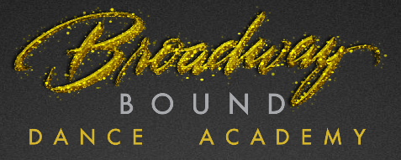

**SUMMER TUMBLING PROGRAM**

Broadway Bound offers several classes and levels to fit your child’s tumbling needs. All tumbling options are taught by a professional tumbling instructor with years of experience in the recreational and competitive circuits. Please contact the studio in regards to placement.

**\*Classes and times are subject to change.**

**\*\*Students need a tank/leotard & shorts. Hair must in a pony tail, please.**

**Intermediate / Advanced Tumbling**

TWO 8-week sessions this summer

**May 12 – July 5**

Wednesdays 6:15p-7:15p

Wednesdays 715p-815p

Thursdays 530p -630p {or}

730p-830p

**July 6 – August 31**

Tuesdays 7p-8p

Thursday s 7p -8p

**$115: 1 hrs /week**

**$191: 2hrs /week**

**Beginner**

**Tumbling**

TWO 8-week sessions this summer

**May 12 – July 5**

Tuesdays 6p-7p

Thursdays 430p -530p

**July 6 – August 31**

Tuesdays 6p-7p

Thursdays 6p -7p

**$115: 1 hrs /week**

**$191: 2hrs /week**

**OPEN GYM Tumbling**

**May 12 – August 31**

Tuesdays 8p-9p

**$10 per student per visit**

**SUMMER TUMBLING PROGRAM, cont.**

**St. Columban cheer tumbling**

**July 6 – August 31**

**Monday and Wenesday Evenings**

*\*Open to St. Columban Cheer Students ONLY\**

Beginner Skill Level: 6pm – 7pm

Intermediate/Advanced Skill Level: 7pm – 8pm

**LYF Cheer tumbling**

**May 12 – July 5**

**Thursdays 630p – 730p**

*\*Open to LYF Cheer Students ONLY\**

**LMS Cheer tumbling**

**May 12 – July 5**

**Tuesdays 7p – 8p**

*\*Open to LMS Cheer Students ONLY\**

**Indian Hill tumbling**

**May 12 – July 5**

**Wednesdays 615p – 715p**