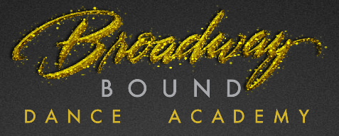

**Summer Fun**

**Summers at BBDA offer a variety of fun, learning activities for your dancer choose from:**

* Condensed versions of our most popular dance classes in 4- 8 week sessions: Beginning June 23rd.
* 8 week tumbling courses: Beginning May 12th.
* Dance activity camps designed for 3-5yr old dancers with 4 different themes to choose from. The 4- day camps are filled with fun, dancing, crafts and an opportunity to perform with their costumes/crafts at the BBDA open house! (M,T,W, TH 10a-1p)
  + Princess/Super Hero Theme: June 23 – 26
  + Frozen Theme: June 30 – July 3
  + C:\Users\nlarosa\AppData\Local\Microsoft\Windows\Temporary Internet Files\Content.IE5\WWAEPL3N\MC900055276[1].wmfUnder the Sea Theme: July 7 – July 10
  + Jungle Book: July 14 – July 17
* Dance Company Intensive
* Dance Competition Team Intensive
* Private Dance Instruction
* Private Tumbling Instruction
* Open Tumbling Gym

**For more details visit www.broadwaybounddance.com**