Town of Westport

Master Plan Public Workshop #4 Summary

The Westport Master Plan Committee (MPC) hosted the first public workshop on the Master Plan Update on Saturday, February 7, 2015 from 9:00 AM to 12:00 PM at the Westport Public Library. The purpose of the workshop was to introduce and gain public input on the Education Element.

An interactive break-out exercise was used to elicit community input regarding local challenges, opportunities, goals and objectives related to these elements. Twenty-four participants registered on the sign-in sheets representing a variety of Westport stakeholders. The following is a summary of the feedback received at the workshop.

Registration

As participants arrived at the workshop, they were greeted by the Town Planner, members of the MPC and/or the consultant team from the Horsley Witten Group, Inc. (HW). Agendas, nametags, and handouts were provided as they signed in at the registration table. Refreshments were donated by the MPC members. There were posters showing the community survey results and community maps on display for participants to view during this time as well.

Opening Remarks and Presentation

Jim Hartnett, Westport’s Town Planner, greeted the participants. Elaine Ostroff, Westport Planning Board member and Chair of the MPC provided an overview of the update process. Westport Community School Superintendent, Ann Marie Dargon, also addressed the group and encouraged them to visit their website to view their vision and district goals.

The Town’s consultant, HW, was introduced. Their role in the process has been to facilitate four public workshops as part of the Master Plan update. HW provided an overview of the Master Plan, the update process, including the background and purpose of the Community Master Plan, some example projects that came out of the 2004 Master Plan, and the tasks to accomplish for updating the Master Plan. The Westport Master Plan will be comprised of ten elements, the final element, Education, was the focus of the day’s workshop.

HW then “set the stage” for break-out exercise by reviewing draft goals and objectives related to Education. HW then introduced the purpose and directions for the break-out exercise itself.

Break-out Groups

Three sub-topics of education were discussed:

- Community engagement and public relations
- Facilities
- Financial resources
Due to the limited time available, each attendee was able to participate in two break-out group discussions. For the first round, HW assigned attendees to one of the three tables by having them count off. Attendees were free to pick their preferred topic for the second break-out group.

HW facilitators guided the discussion of their break-out group around two questions:

- Are there any big ideas missing from the draft goals and objectives?
- What specific actions can we do to achieve these goals?

After the facilitator read the first question aloud, group members worked individually for a few minutes to write down their thoughts on a worksheet. These worksheets were collected at the end of the workshop. Each group member was then provided the opportunity to share one idea, noting that their other ideas written down would also be considered. If time allowed, group members provided additional ideas after each person shared their first idea. Responses were recorded on a flipchart.

Each break-out group had a bubble diagram poster-size in the center of the table that depicted key phrases of each goal and objective related to the sub-topic. Attendees were encouraged to use the diagram to answer the two questions. Refinement related to new big ideas or action items was made to the diagram.

The following is a summary of the discussion that came out of both groups.

Communications and Public Relations

The discussion of communications and public relations focus around what both groups identified as the “myth,” that Westport Community Schools did not offer a quality education, and this was the largest challenge to overcome. The accomplishments of existing students and faculty as well as alumni need to be showcased as a way to rise above the negative image.

One of the “big ideas” discussed to meet this challenge was identifying an advocate and/or liaison on behalf of the Westport Community Schools. They would be the point person between the schools and the general public. Their job would be to attend meetings of diverse committees, organizations and groups, including town meeting, to provide information about what is happening in the schools. Parents should also be encouraged to be advocates for their schools. Many are unfamiliar, or even intimidated, by the town meeting process. It is important to educate them on the governmental process and how they can use the meeting to promote the schools and gain support for school funding. Offering child care and other incentives to encourage them to attend town meeting (and other organized meetings to promote schools) should be part of the effort.

In addition to having an advocate, the school department and committee need to establish a two-way communication with the public, drawing them into the schools in a variety of ways. Some examples might be internships with local businesses and organizations, guest speakers in the classroom, increasing activities for the general public at schools (e.g. adult education classes or exercise classes) and promoting school-sponsored events such as sports or cultural activities.

Revisions to the draft goals and objectives were also provided by the groups during discussion. Specifically, Goal 1 should put less emphasis on college and standards, and focus on broader career routes and goals instead of standards that move students forward to be successful. A more overarching goal should also be drafted should state that the goal of public education is to prepare students to be responsible, engaged and productive citizens.

Below are notes from each group discussion that were taken on flipcharts. The “Communication and Public Relations” worksheets handed in by individuals are found in Attachment A.

Group #1

Big Ideas
- Using technology to engage community
- Understand how funding impacts the quality of schools
- The community doesn’t understand the quality of education in Westport and those that do attend and their success.
- Get the community more involved – even those without children. Create pride, and promote what students are doing (e.g. sports)
- How the schools influence the outlook of the town, e.g. known for not funding schools
- Also non-technical ways to communicate with community
- Establish a process to coordinate the use of school buildings. Get the public in the school buildings through events, adult education, online classes
- The negative thinking about the school system and its effects on property values – it is a misunderstanding = “the myth” = it is a good school system and graduates have gone on to be successful
- There needs to be two-way communication between the school department and the public/community
- Private choice to send children to other schools is impacted by “the myth”
- Engage the public to be a part of the school, multi-generations.

Actions
- Identify a school liaison/concierge as a person to call to use facilities, media to promote school. Some of this already goes on, but needs to be expanded.
- Reach out to other organizations (e.g. environmental groups) to come into schools
- Have a routine, or regular schedule of activities, e.g. a monthly open house when there is something to see at the school, fun activities
- Have a monthly info-mercial to share and reinforce positive aspects about the schools
- “Get people into the building” – some ideas: workout/gym after 5 pm.
- Barriers to getting into schools:
  - Doors/locks
  - Insurance requirements
  - Maintenance during after hours
  - Security
- Create a volunteer network of different groups/organizations/town committees to share with new concierge
- Work with local businesses and organizations to establish student internships (use those with positive experiences to promote to others); e.g. working with seniors, “seed savers” project
- Streamline the process to access school buildings
- Hold community classes lead by school staff in school buildings – go over lessens that are being taught, e.g. new math
- Develop a way to share opportunities and events with the communities
  - All town departments/events linked online
  - Online “one stop shop” for whole town – simplify the town’s current website
  - Use multiple ways to reach out
- “Partying” – hold events, encourage different groups to get together

Group #2

Big Ideas
- Focus on the real purpose of public education – to develop citizenship skills, be responsible and engaged citizens
- There needs to be more positive advocacy for the schools that leads to…
  - support of funding
  - more kids staying in the public school system
- All citizens of town benefit from a good school system. A good school system attracts young families that become involved in the local community.
- Create a system that the community takes pride in and develops students in what they pursue
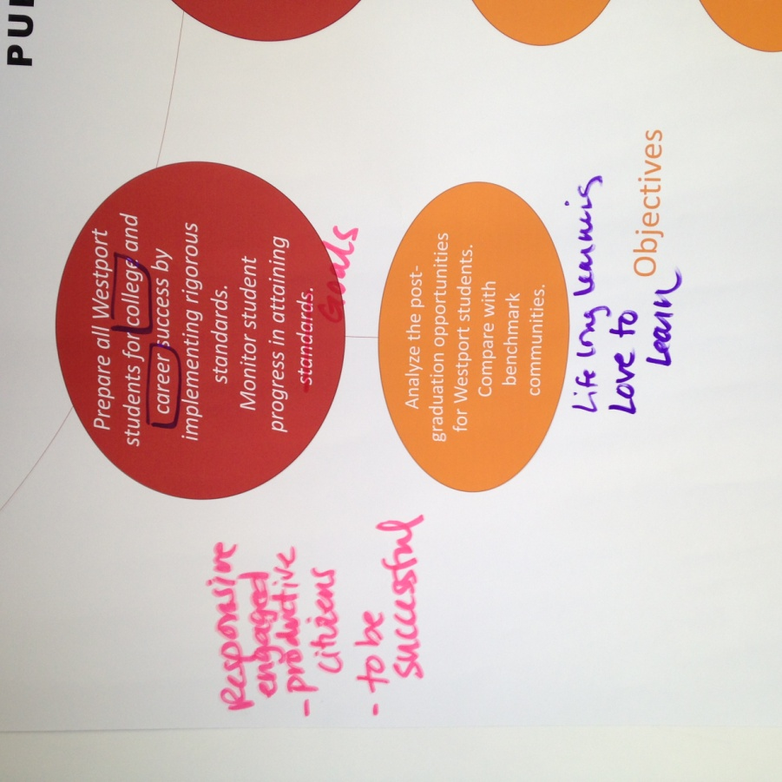
- The school department needs to be prepared for moving projects forward: know how much projects are going to cost, do their homework, before going before the Board of Selectmen and the public. There needs to be better communication.
- Not all students go to college, and the objective on the chart needs to be broadened [see notes on bubble chart]
- Add lifelong learning to objectives [see bubble chart]
- The school department should develop three goals that half the town population knows. Keep them simple, understandable and bold.
- There needs to be an advocate for the school system that goes to each town meeting to promote it.
- Pride is needed. If people have pride, they talk about it in schools.
- Establish neighborhood schools.

Actions
- Establish neighborhood schools as a way to reach out and bring public into schools
- Advocates for the school system that promote the positive and good things going on.
- Grants to develop democracy education
  - Community interaction, they see what’s going on in the school
- Get kids into the community through community service
- Parents are missing at town meetings – how to get them there
  - Provide a place for them that is welcoming
  - Educate about the government process
  - There is a perception at town meeting that they are only voting for money
  - There could be an informational session before voting at the town meeting
  - Need to make provisions for parents (e.g. child care)
  - Build up momentum to the town meeting.
- Have meetings/ “Coffees” on different topics related to the schools.
- The school system has a product to see – use the 3 goals pitch.
- School department – stay the course and follow through a project to completion to show accomplishments
- Develop talking points that are consistent, like a “Campaign”, something that is relevant across mandates, government, elected officials
- Get parents to choose public schools
- Have community members with expertise or a skill set come into the school, get them to see inside the schools
- Establish partnerships with businesses and environmental groups – a career day
- There is a loss of parents volunteering at the high school.
- Why are parents not sending their kids to public schools – ask. The Superintendent is doing this now.
- Have representatives advocate for Chapter 70 funding for fair distribution – Westport’s contribution to be proportional to others at Diman and Bristol Aggie.
HW Recommendations Moving Forward
- Setting high educational standards and improving student performance have typically been the goals of a school committee, which has the resources and knowledge base to develop policies and implement actions to meet these goals. This is no different in Westport. The Westport School District Improvement Plan lays out the District’s goals and strategic focus areas district-wide and by school. There are two approaches the Town could incorporate these into the master plan. The first approach is to ensure that draft Goal 1 and its objectives and action items are in alignment with the District Improvement Plan. An alternative approach is to reference the District Improvement Plan. The latter approach would ensure consistency as the District updates its plan.
- The master plan is an opportunity to provide the connection between the school district and the public, particularly with those that do not have children. It is an opportunity to “take a step back” to look at the big picture, and focus on assessing the impacts a quality education can have on a community as a whole. For example, a community with a reputation of having good schools will attract young families, which may be looking for starter homes they can afford and jobs within a short commute. With this in mind, the master plan can lay out goals and objects to build a communication strategy that promotes Westport Schools and attempts to dispel the myth that it is not a good school system. The Goal 2 and its objectives in the draft master plan are consistent with what was heard at the workshop.
- The draft master plan also has a goal to increase engagement between Westport Schools and the community (Goal 3). Discussions during the workshop clearly support this goal. Many of the actions that were mentioned at the workshop are part of the draft, particularly bringing the public into the schools for special sporting or cultural events, adult education classes, and other activities. This item is linked to the Facilities discussion and barriers that exist in gaining access to school buildings by the public outside of the school system.

Facilities

Similar to Communications and Public Relations, the groups that discussed Facilities felt there was a need to bring the general public into school buildings to help bring the community together and strengthen ties between the school system and the community at large. Some thought that the Town needed a large meeting space where larger groups could meet and where cultural events could take place and the schools were an opportunity to meet this need. They are currently underutilized. Efforts should be made to inform groups about the space, encourage use, and remove barriers where possible. Bringing groups into the schools can increase awareness of what’s going on there and in turn garner financial support for schools. It can also cultivate more engagement between the community, the schools and school programs.

School buildings must also meet the needs of students and faculty to offer a quality education. Older schools have equipment that is broken, highly worn, or outdated. Modernization is needed. HVAC upgrades to improve temperature control and sound-proofing needs are also critical. Improving school facilities also extends to the water supply systems and septic systems at the schools, some suggesting that they are reaching the end of their useful life and are already causing problems

Several participants pointed out that a segment of the school population is not being serviced, particularly those not interested in attending college, or not immediately attending post-secondary education. The students will enter the workforce after high school but with fewer skills than those exiting vocational schools. Westport’s schools need to address this concern, and it will mean some new and different facilities to serve this population. One approach would be to dedicate some building space(s) to activities that will help non-college bound students gain skills to make them competitive in the business environment. Some mentioned that Westport students have only 23 slots at Diman each year, and these are filled based on merit, leaving perhaps the most likely vocational oriented students with a less than ideal curriculum.

Finally, some participants noted that due to funding cuts, there are fewer extracurricular activities. This affects the school and the community in two very significant ways. First, the facilities that supported the extracurricular activities are deteriorating and/or being neglected, wasted and forgotten. Secondly, the loss of these activities is affecting the vibrancy of the schools themselves, the amount of engagement with parents, volunteers, and the community as a whole, altogether to the detriment of students and educational excellence.

Below are notes from each group discussion that were taken on flipcharts. The “Facilities” worksheets handed in by individuals are found in Attachment B.

Group #1

Big Ideas
- Larger meeting space is needed for community events
- Sharing auditoriums & Athletic Fields
- Adjustable classrooms to meet changing needs in education
- Outside the class learning
- Community members into the classroom
- Public support and engagement
- Facilities not over-arching
- Facilities, problem solving, critical thinking, arts
- Ask the educators and the students what they need
- Strengthen K-8 facilities
- Tap into programs outside Westport
- Furniture needs updating
- Concern with interim plans; appropriate use of resources
- Central place for gathering – Town center
- Can we maintain it? $$
- Opportunity for outdoor facilities
- Potential for expansion; acquisition for the long term
- Build public support for facilities
- Keep it simple; better focus on school objectives
- Should there be discussion of distributed facilities

Actions
- Items need to begin now
- Long term active building committee
- Comprehensive look at all building issues needed – need professional advice
- Make use of Roger Williams University services – Architectural outreach
- Can Bristol Community College provide services in Westport Schools?

Group #2

Big Ideas
- Options for all students; competitive skills; some students left out
- Multi-use school facilities
- Long range Planning (10-15 years)
- Large auditorium
- Prepare and ACT on the plan
- HVAC/Sound proofing all schools
- Basic infrastructure needs – Water and Wastewater
- Better coordination among public and private facilities
- Combine facilities in one/central location
- Attention to equipment needs
- Modernize IT
- Space flexibility and accommodate modern needs
- Changing demographics driving need for more integrated school/community uses
- Improve interconnectedness with the community

Actions
- Educate public on school needs
- Publicize facts on school facilities/availability
- Address facilities’ needs so that the Superintendent may focus on education
- ACT on the recommendations
- What do students need? Build it! Vocational & College Prep
- Need more extracurricular activities; limited investment being made to support these

HW Recommendations Moving Forward
- Action items, and perhaps an objective, should focus very concretely on the dissemination of information. As with the school budget recommendations below, the Town should set up a formal system for gathering, organizing, and publicizing information on school facilities. Organized transparency will be critical to building trust and leveraging investment.
- Consider some bartering with professional development organizations. If they have equipment or furniture they could provide to the schools that would be useful, the school could provide classroom space in return.

Financial Resources

There was significant overlap between the Financial Resources group discussion and those of other groups, particularly related to issues of public perception. While participants were quick to begin the discussion with the observation that funding for schools is inadequate, they were much more interested in discussing the public perceptions around this issue. According to participants, the disconnect between the reality of the school budget and the broader perceived reality is perhaps the largest barrier to solving the problem. In the view of participants at the table, there’s a significant financial gap between what the school system can afford to provide and what students should have in order to have the educational experience residents want them to have.

The reality of the budget situation is that parents are required to pay fees for many activities and services that were once provided as part of the normal course of everyday public school experience. Additionally, money raised by volunteers plays a significant role in closing the gap on some of these basic services. Some participants were concerned that parents were “burning out” on donating their time and money for services and supplies that they feel should be provided through public funding. For those in the community not directly involved with the school system or without school aged children, there is often a perception of “things seem to be going fine”. Without the day-to-day contact with the issues, many residents are not exposed to the reality of the budget situation and, therefore, do not approach funding issues at Town Meeting with any real sense of urgency.

Another barrier to increasing school funding that was voiced by both groups is a general lack of trust in local government spending. There were several anecdotes about prior municipal initiatives that did not achieve the results tax payers expected. These individual events add to the mistrust created by what participants felt was poor communication by the Town on financial issues. The manner in which budgets, projects, and overrides are presented can leave residents confused and/or misinformed. There were many suspected reasons for this, but most felt that a lack of centralized management in town government makes it next to impossible to integrate information across department effectively and present information in a manner that is transparent and informative.

Finally, another theme that came from both groups is the encouragement of multi-use and revenue generating utilization of school buildings. While some participants approached this cautiously and others with great enthusiasm, there was consensus that the idea should definitely be explored. Reaching out to regional groups, especially those that provide classes and training, was viewed as an important next step in identifying potential “customers” who might want to rent classroom or other facility space.

Below are notes from each group discussion that were taken on flipcharts. The “Financial Resources” worksheets handed in by individuals are found in Attachment C.

Group #1

Big Ideas
- Need more funding
- Perception of the school formula is that there is adequate money
- Parent and community members feel that success of the schools indicates that funding levels are adequate
- Local resources need to increase
- How do we get support?
- How do we buffer impact of regional school formula?
- Can there ever be enough?
- There’s lots of money – we don’t know how to “talk to it.”
- There is too much focus on new school spending (% has increased)
- Parents are burning out with fees
- Adversarial school committee and staff
- Funding is a guessing game
  - Free cash (informational)
  - Override will be impossible – there is a lack of trust
    - Middle school example
    - No tracking
    - Mobile unit cost example
  - When override doesn’t pass, there’s no public reaction
  - State funding gets cut
- Regional vocational is now a competition – college prep
- Lack of alumni involvement – parents “drop out” when kids move on
- Reduce dependence on taxes
  - Look town-wide

Actions
- Issues need to be communicated to the lay person in a way that’s clear and comprehensive
  - Town needs to work HARD on developing effective communication pieces.
  - Budgets and issues need to be effectively organized and summarized
  - Residents need to see school budget in context of entire budget
- Separate overrides, don’t put them all in one package
- Transparency must be provided on where money is going. This may be the most important issue regarding trust in local government spending.
- Talk to universities
  - What are they looking for?
  - How do we better engage universities and funders?
- Volunteer investment is not documented and communicated to the broader community

Group #2

Big Ideas
- How does funding occur now?
  - More than town government funding
  - PTO contribution
- Think of schools as “profit centers” (Barrington “Shorelines”) – partnerships
- 2/3 of the town is not engaged in school – no children/no school kids
- Should we consider a professional Grant writer? Fundraiser?
- Careful management of money with transparency
- Bond (temporary) vs. override (permanent)
- “Race to the Top” = example of an opportunity that should be used to generate excitement
- Measure what we accomplish – is my investment paying off?
- Public invited in and informed – there is a policy in place
  - Rental fee is charged if someone is not from the school
- Large amount of money spent on a specific area, but residents don’t support with a vote.
- Marketing – physical connection to tax dollars
- What’s the history on reduced funding? Parents are covering the difference.
- 501(c)3 as a possibility

Actions
- How do we educate?
  - Create a cost scenarios including the cost of ‘no action’
  - Invest in voter education/civic education
  - Start with basic goal of quality education
- A working group had existed – revisit
- School committee – Can provide leadership. Provide information. Be an advocate.
- Door to door education campaign. Develop the facts.
  - Cost of different actions
  - Reality of budget
  - Reality of sources
  - Why it’s good
- Conduct a cost/benefit of renting out school space
- The first word in the Goal “Provide”…replace with “invest”
- Explore school buildings as multi-use facilities
  - College rental
  - Adult education
  - Regional
- Squarely address real cost of equipment and salaries. This is not the 1970’s! Provide education on the cost of good personnel.
- Clearly answer “What is the override for?”

HW Recommendations Moving Forward
- The action items listed above should be discussed within the committee and potentially refined for inclusion in the plan.
- The discussion of transparency and communication regarding budgets and spending was very compelling and gets to the heart of a big issue in Westport. HW recommends that a new goal should be included here about this issue. Language would be worked through by the committee, but by way of illustration it could sound like “Implement a comprehensive and transparent system of communication regarding the municipal budget”. Objectives underneath this might deal with coordinating municipal departments, providing educational materials, and doing outreach specifically for budget issues.

Closing (11:30 AM – 12:00 PM)

After the break-out exercises, participants convened into a general session. HW facilitators reported out to participants on the common themes that were discussed among their groups. Jim Hartnett closed the workshop by thanking the public for coming and for providing valuable input for the plan. Participants were encouraged to contact the Planning Department, Planning Board, or Master Plan Committee with any follow up questions or comments.

