Attention: Bargain Hunters or Those Who Love to Buy at a Discount, this Coagulation Cascade is On Sale!

For 37 cents, you can purchase the extrinsic pathway. (factors III, VII)
If you can’t buy the intrinsic pathway for $12, you can get it for $11.98. (factors XII, XI, IX, VIII)
The final common pathway can be purchased at the Five (5) & Dime (10) for 1 or 2 dollars on the 13th of the month. (factors V, X, I, II, XIII)

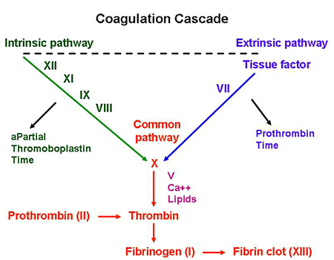
*Tissue Factor is factor III

